

A Project Report On

**School Management System**

**By**

**Batch: 2021-6526**

**Under the Guidance of,**

**Chittaranjan Ghosh.**

**Technical Trainer**

**EduBridge**

**(School of coding)**

## Introduction:

A School Management System is an information management system for educational institutions to manage all student's data. It provides abilities such as registration of students in classes, documenting of grades and analytical marks of each student and other evaluation elements. In addition, an School Management System is used for planning students’ curriculums, recording their attendance and managing all student-related needs within a school.

School Management systems vary in size, scope, and abilities, from packages implemented in relatively small organizations to cover student records.

* **Modules:-**
* Student Module
* Recruiter Module
* Admin Module

I have developed this Application in **Java core,** this is core project**.**

* **Software Requirements:**

**Back end**: MySQL workbench 8.0 CE

**Operating System:** Window

* **Data Dictionary:**
* Create Database SCHOOL

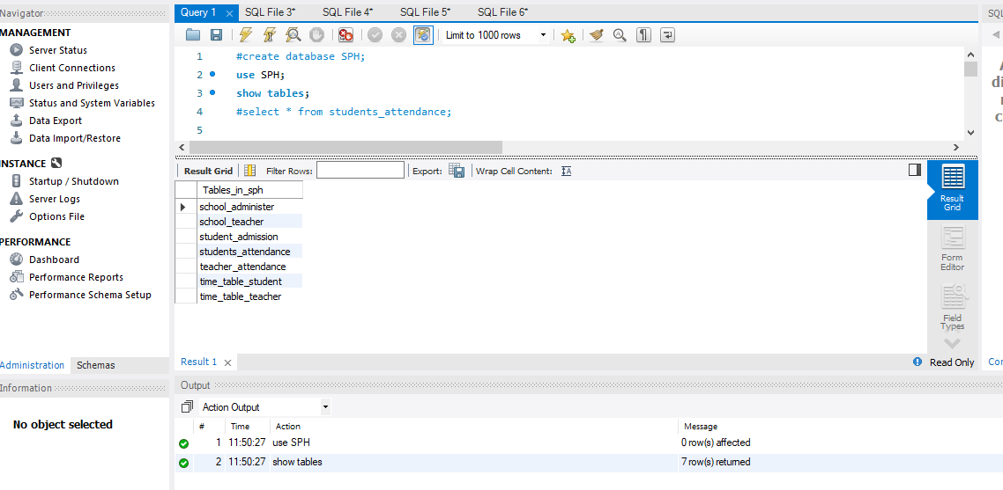

* Create Table for student_admission.

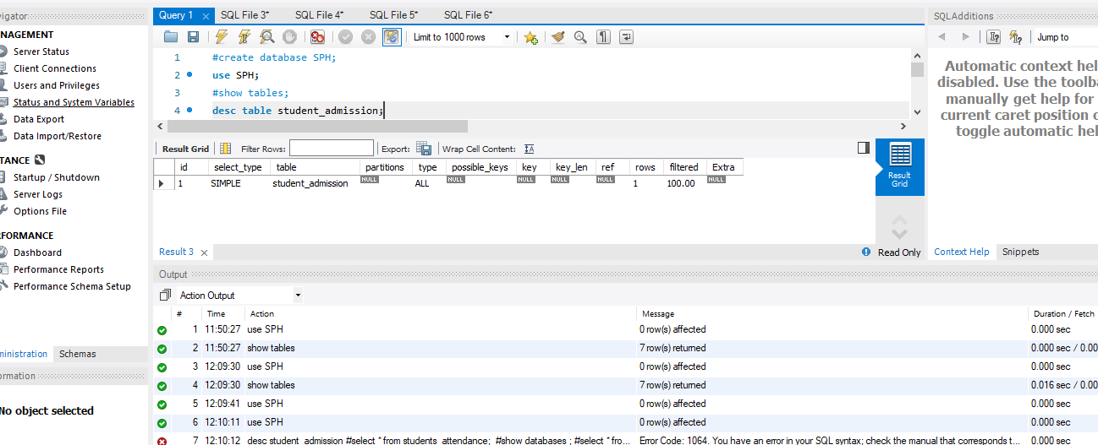

* App Interface For School Management System .

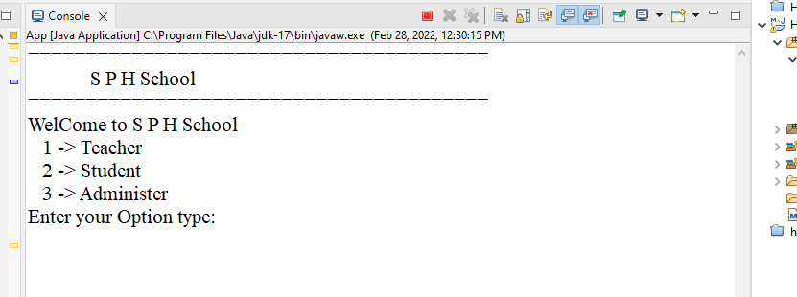

* App Interface for Teacher.

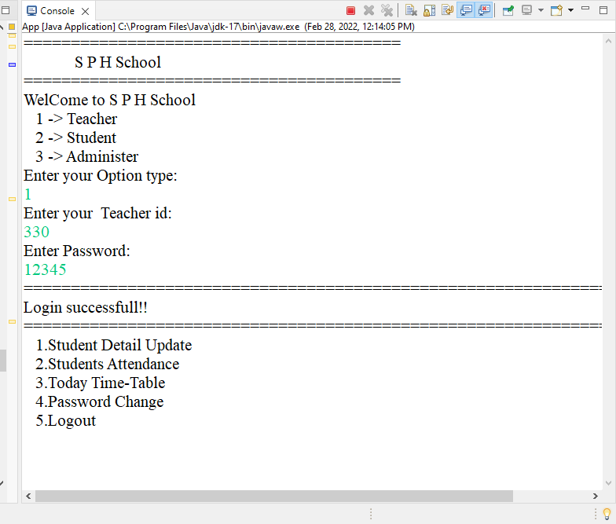

* App Interface for Student.

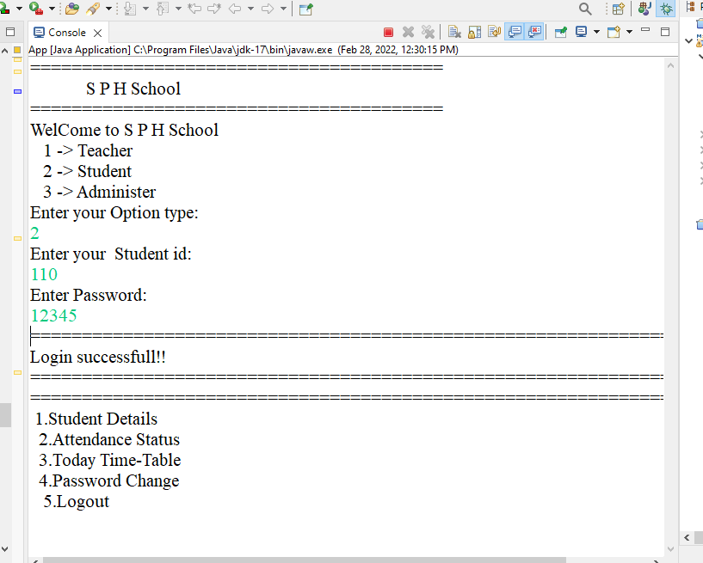

* App Interface for Administer.

